SanDisk 32GB Ultra Dual Drive M3.0 Flash Drive for Android™ Devices - SDDD3-032G-G46

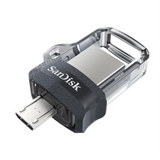

**Dual USB Connectors**:

* **Micro-USB**: For Android™ smartphones and tablets with USB OTG (On-The-Go) support.
* **USB 3.0**: For connecting to PCs and Macs, enabling fast file transfers.

**Compatibility:**

* **Android Devices**: Compatible with Android™ smartphones and tablets running Android 4.0 or later, with USB OTG support.
* **Computers**: Works with Windows 7, 8, 10, and macOS X v10.9 or later.
* **SanDisk Memory Zone App**: Available on Google Play™, allows you to manage and back up files effortlessly.

**Design:**

* **Retractable Connectors**: Protects the connectors when not in use.
* **Durable and Stylish**: Built to handle regular use while maintaining a sleek, compact look.

**Warranty:**

* Includes a **5-year limited warranty**, ensuring reliable performance over time.